Papers written by
Australian Maths Software

YEAR 11
2016

REVISION 3

MATHEMATICS
SPECIALIST
UNITS 1 & 2

SEMESTER TWO
SOLUTIONS

SECTION 1 – Calculator-free
Question 1 (8 marks)
(a)
✓✓

✓✓

(b) (i) 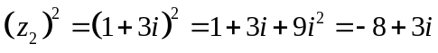
✓

✓

✓

(ii) 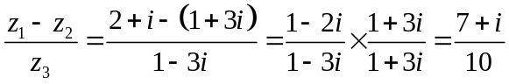
✓

Question 2 (9 marks)
(a) (i) 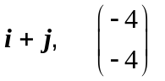
✓

(ii) 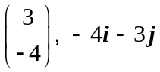
✓

(b) Let 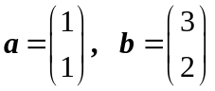
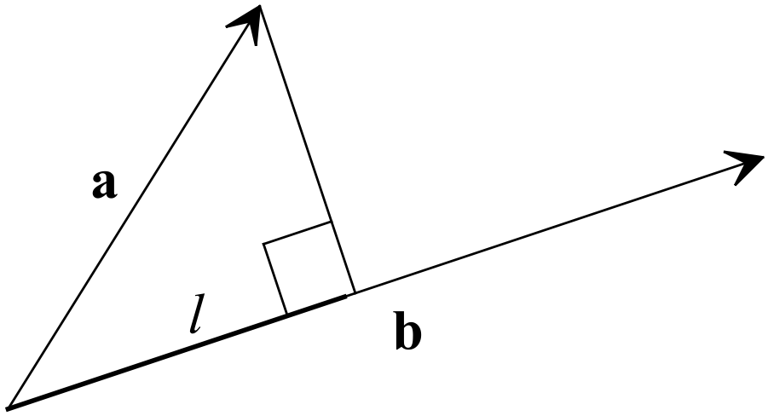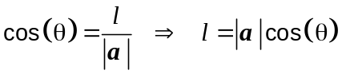
✓
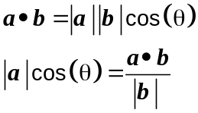
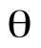
✓
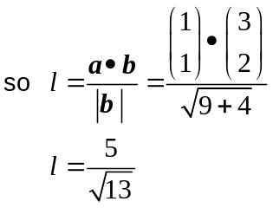
✓
(c) 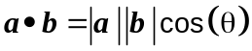
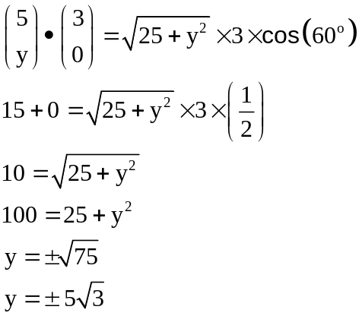
✓
✓
✓ ✓

Question 3 (7 marks)
(a) 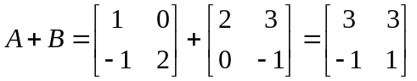
✓
(b) 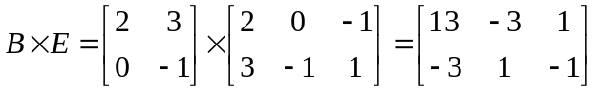
✓ ✓

(c) 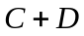=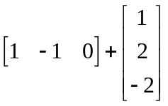 cannot be determined as the sizes are not the same.
✓ ✓

(d) 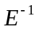=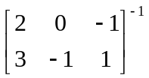 cannot be determined as you can only get the inverse of a square
✓ ✓

matrix.

Question 4 (8 marks)
(a) 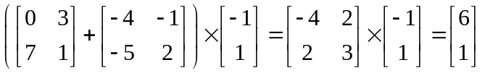
✓
✓
(b) 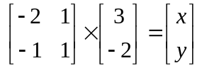
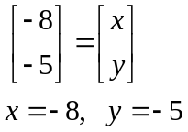
✓
✓

(c) 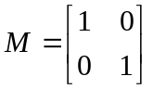
✓

(d) 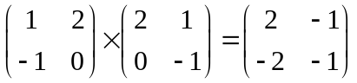
✓
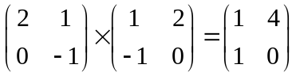
✓
Therefore 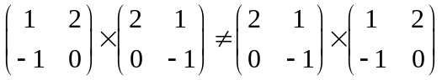
✓

Question 5 (8 marks)
(a) (i) P(x,y) is a point on the unit circle. The height, y= sin(x) and the width, x= cos(x).
This is valid in all four quadrants.
A unit circle has a radius of 1.
Using Pythagoras theorem, 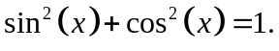
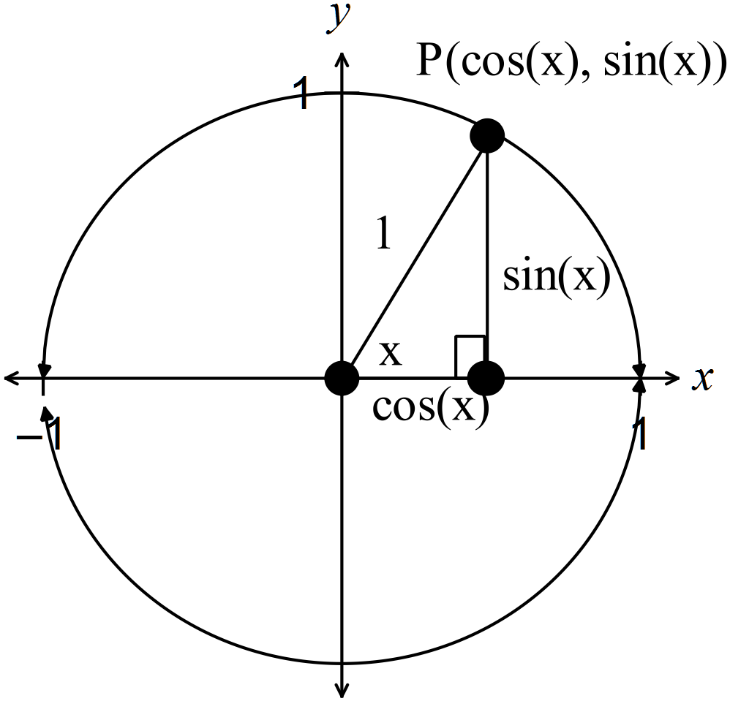
✓
(ii) 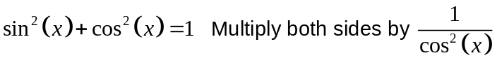
✓
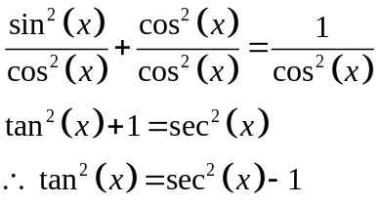
✓
(b) (i) Show that 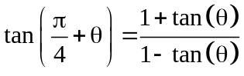.
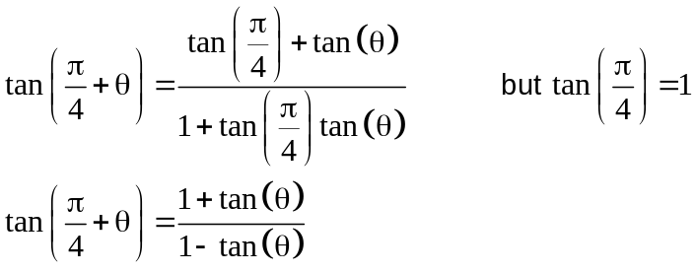
✓
✓

(ii) Show that 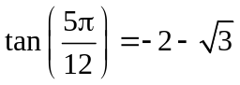.
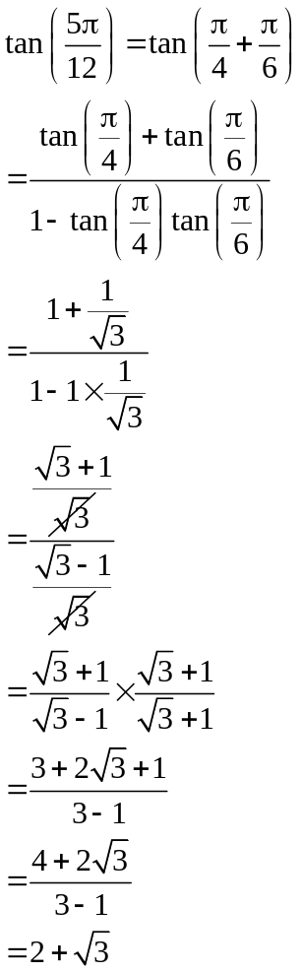
✓
✓
✓

Question 6 (4 marks)
(a) 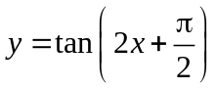
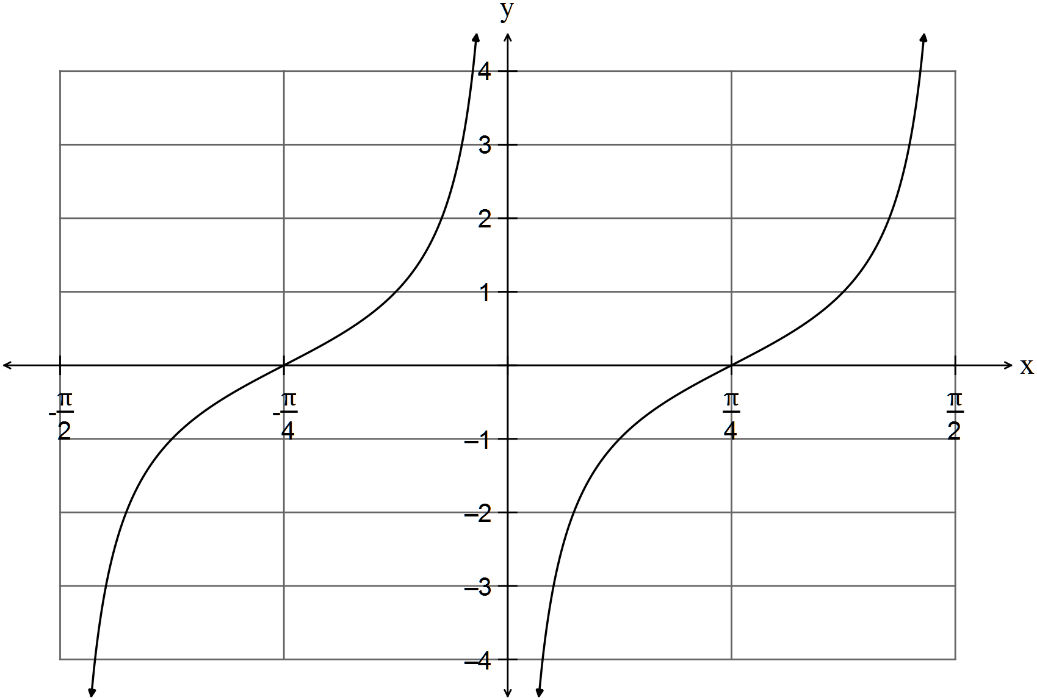
✓✓

(b) 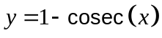
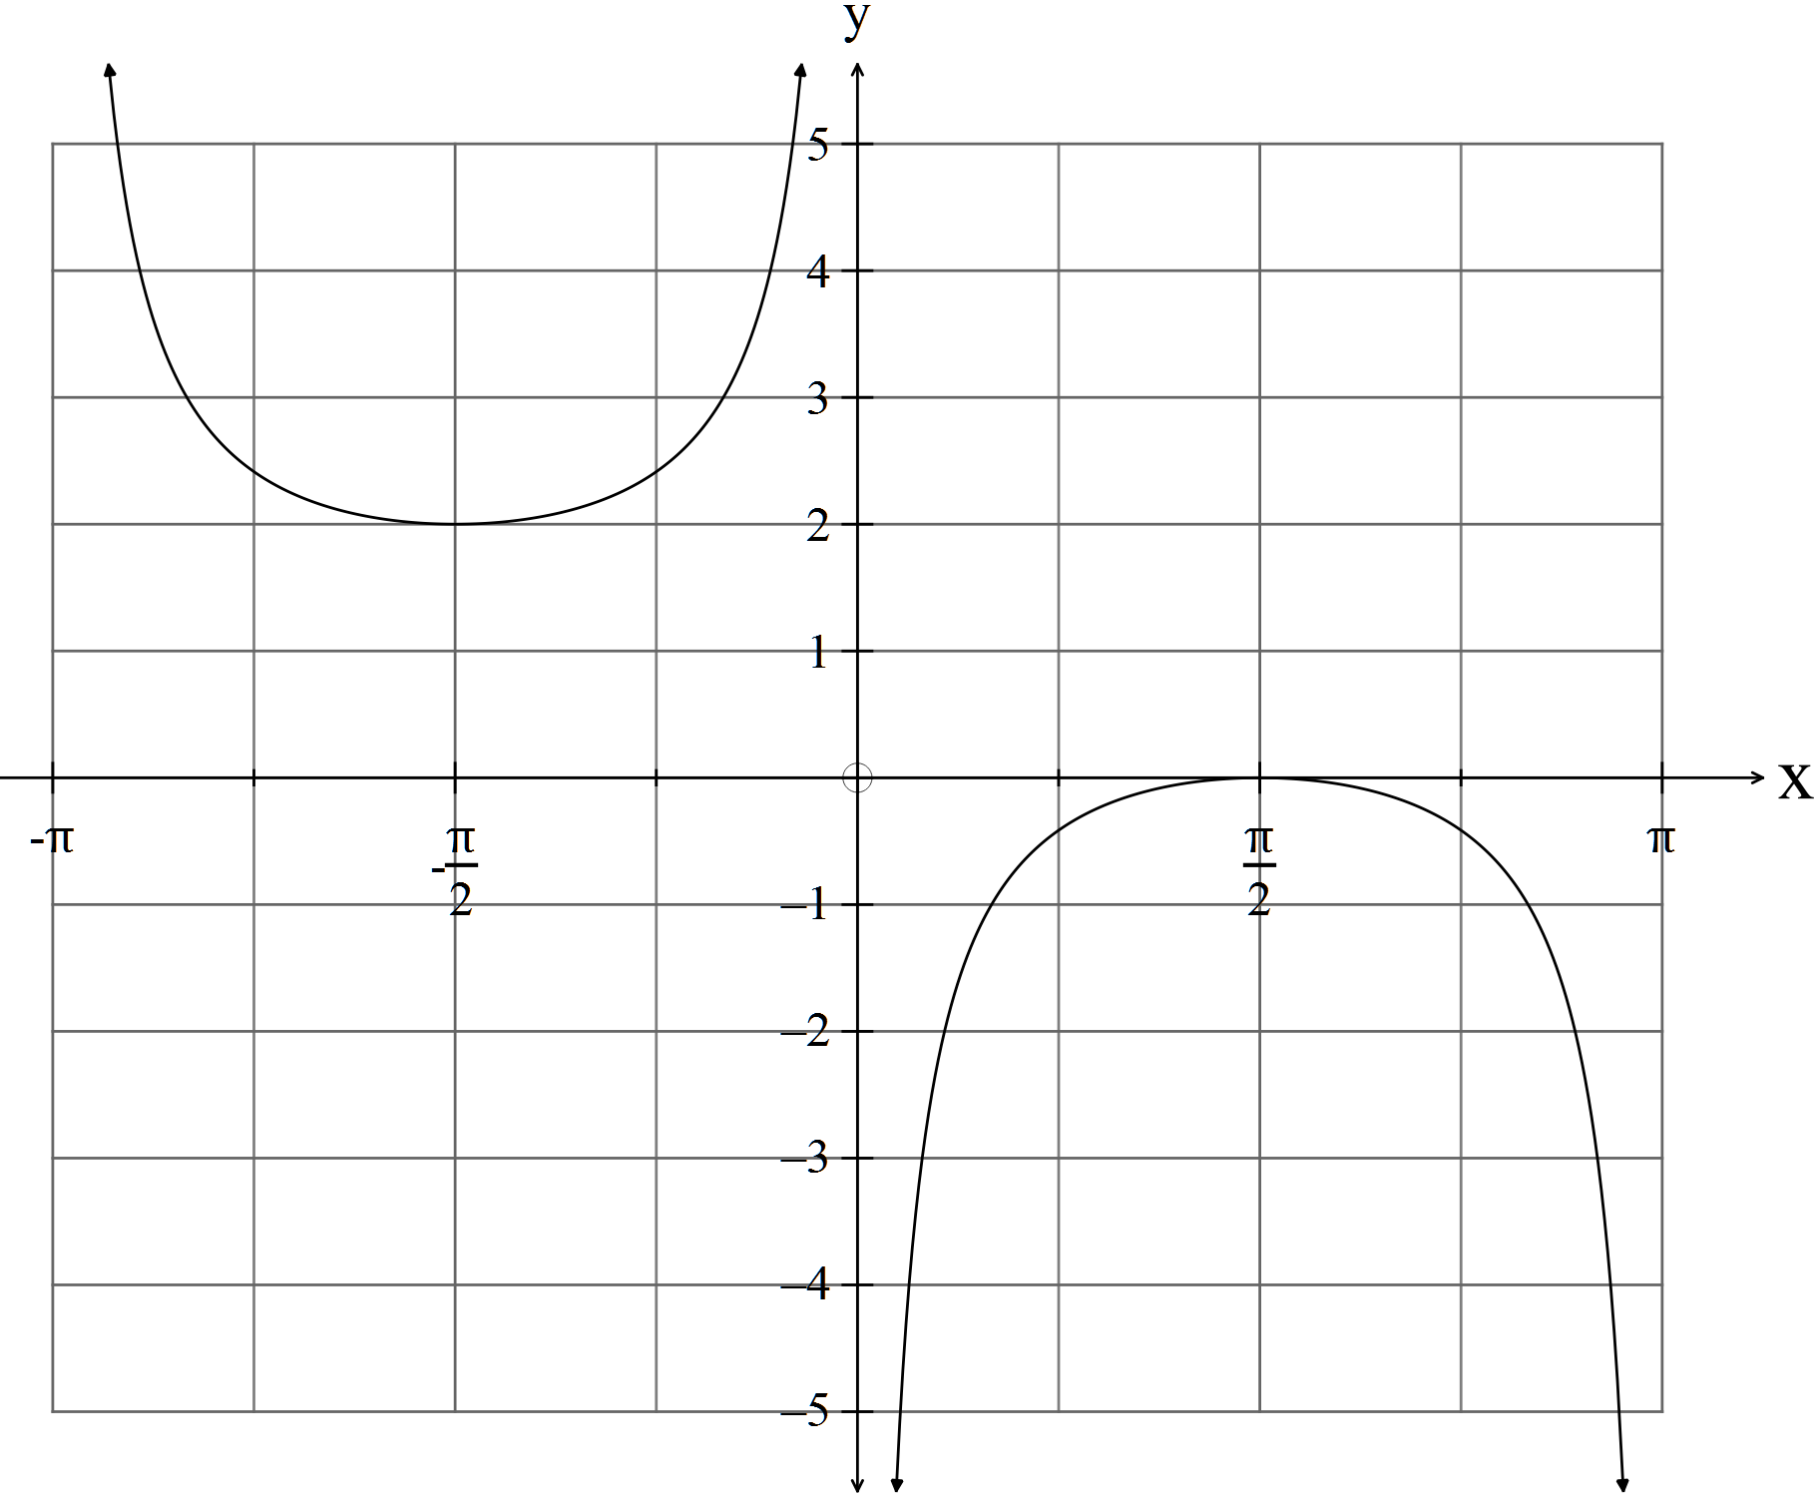
✓✓

Question 7 (8 marks)
(a) It could have been a rectangle. ✓

(b) Prove that “The opposite angles of a cyclic quadrilateral are supplementary.”

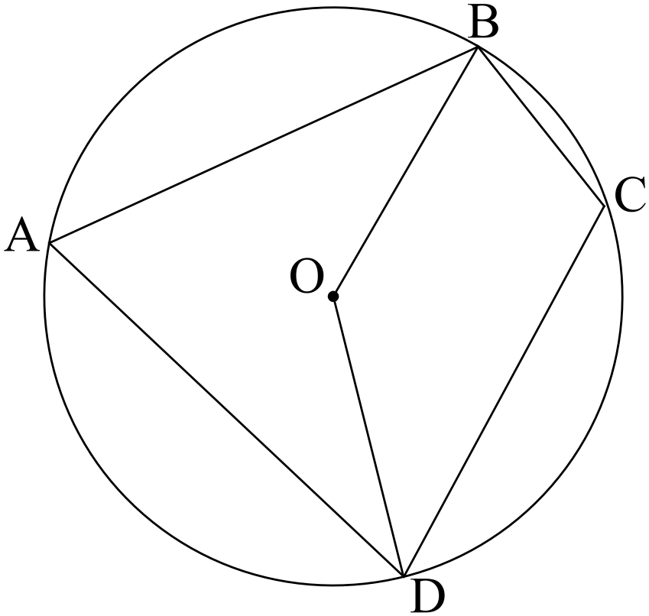

Let ABCD be a cyclic quadrilateral with O the centre of the circle.
Join the radii OB and OD.
✓

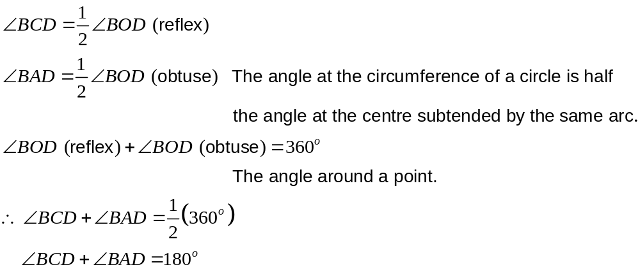
✓

✓

Therefore “The opposite angles of a cyclic quadrilateral are supplementary.”
(c) Prove the following using vectors
“The three medians of a triangle are concurrent at the point of trisection.”
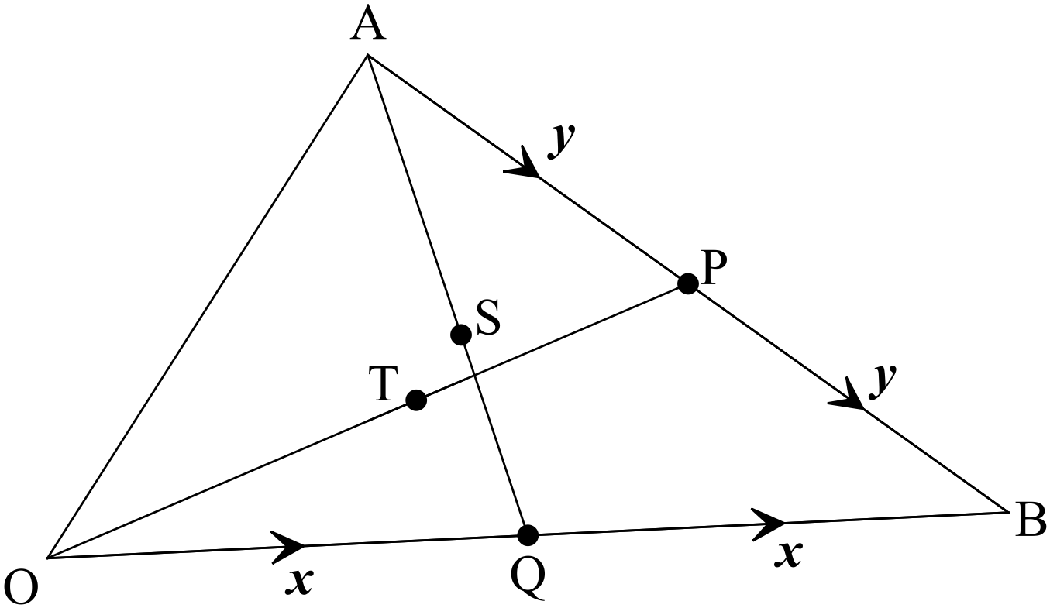
Let ABC be the triangle. P and Q are the midpoints of sides AB and AB respectively.
Let T and S be the points of trisection of OP and AQ respectively.
Let 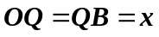
Let 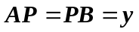
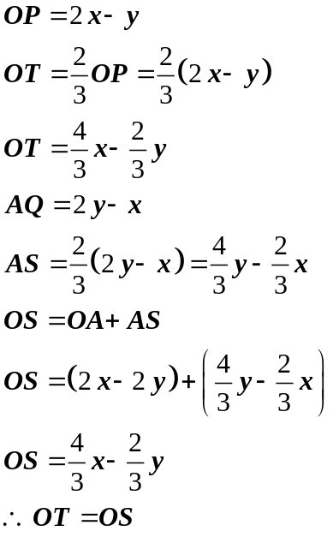
Therefore T and S are the same point.

Likewise the point of trisection of the median from B can be found to coincide with the
other two points.
Therefore “The three medians of a triangle are concurrent at the point of trisection.”

SECTION 2 – Calculator-assumed

Question 8 (7 marks)
(a) (i) 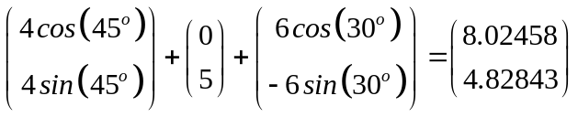
✓

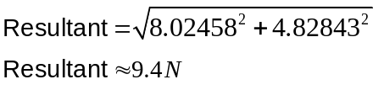
✓

✓

(ii) No, the boys are not in danger form the dog.

(b) Use a vector proof to show that
“The midpoints of the sides of a quadrilateral join to from a parallelogram.”
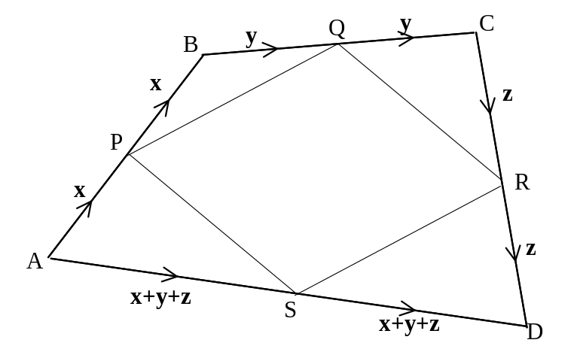
✓
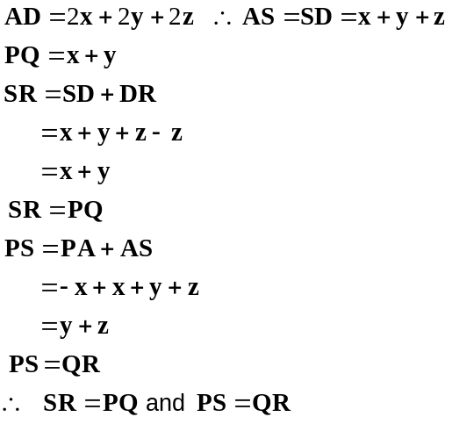
✓
✓
✓
Two pairs of parallel and equal sides!
Therefore PQRS is a parallelogram.

Therefore
“If the midpoints of a quadrilateral are joined, the resulting quadrilateral is a
parallelogram.”
Question 9 (8 marks)
(a) 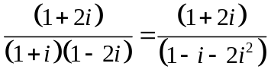
✓

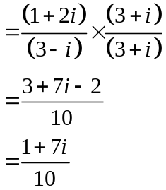
✓

✓

✓

(b) (i) 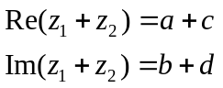
✓

(ii) 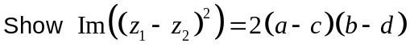
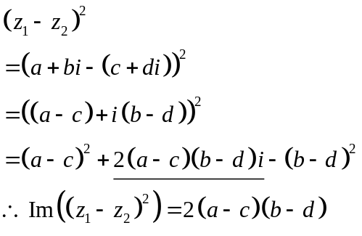
✓

✓✓

Question 10 (14 marks)
(a) (i) 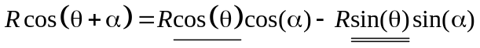
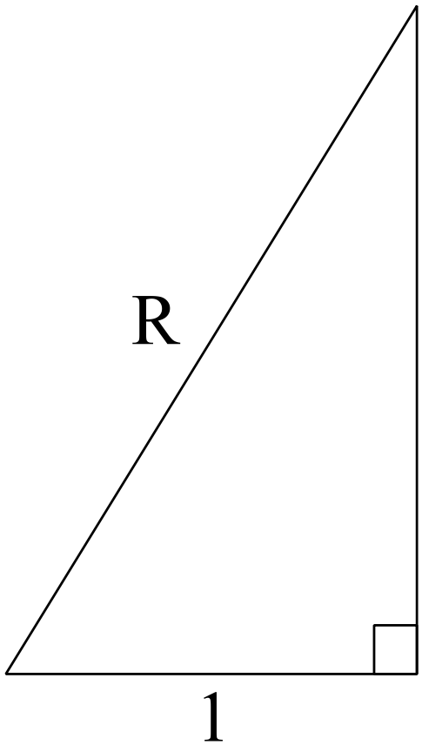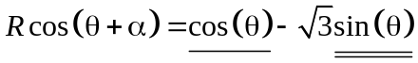
Equating coefficients then
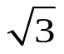
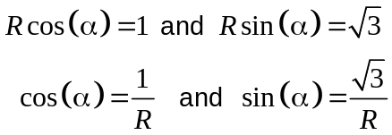
✓
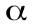
Pythagoras 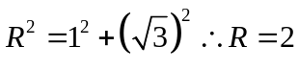
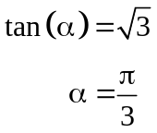
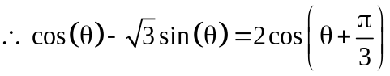
✓
✓
(ii) 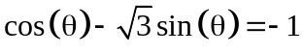
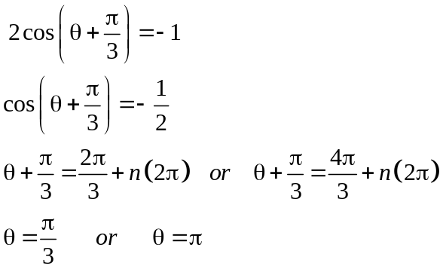
✓
✓
✓
✓
(b) 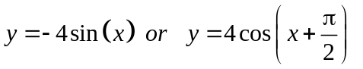
✓✓

(c) 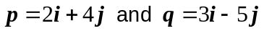
(i) 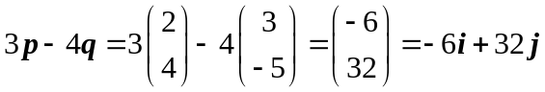
✓✓

✓✓

(ii) 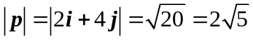
Vector required is 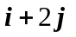 ✓
Question 11 (7 marks)
(a) 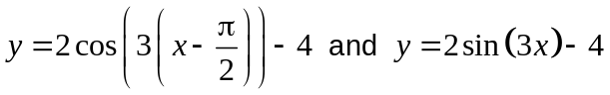

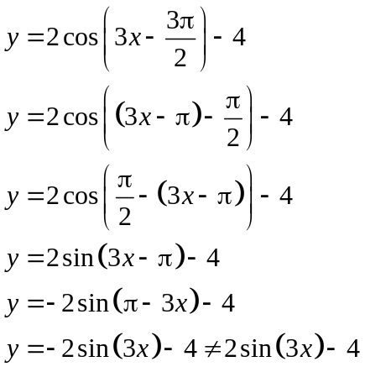
✓

✓

✓

so the functions are not the same
(b) 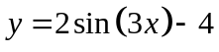
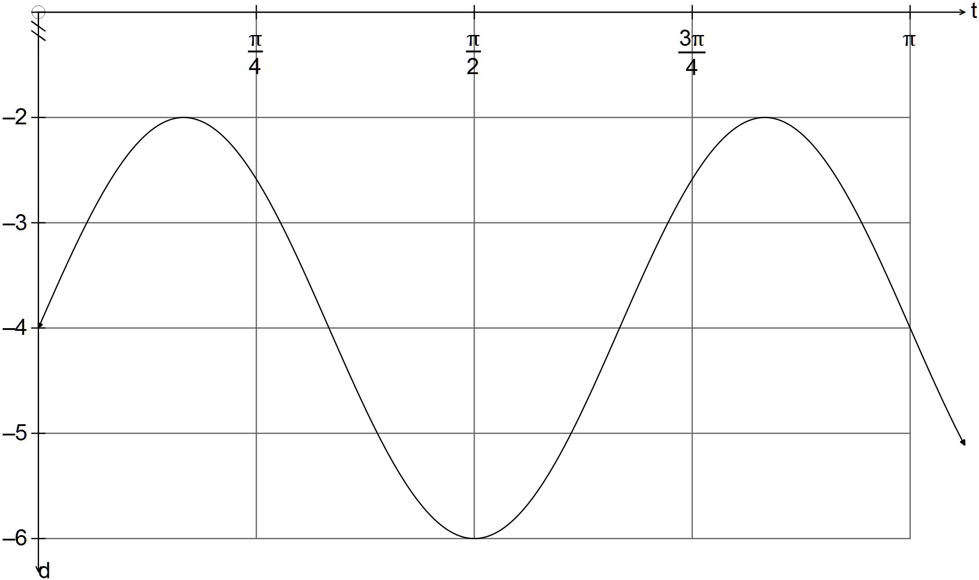
✓✓✓

Question 12 (3 marks)
(a)
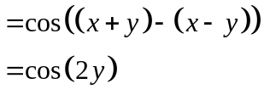
✓

✓

(b) Show
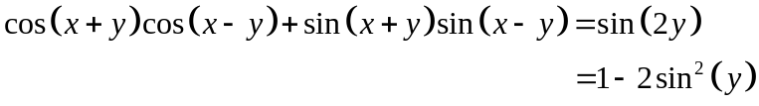
✓

Question 13 (11 marks)
(a) 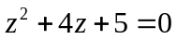
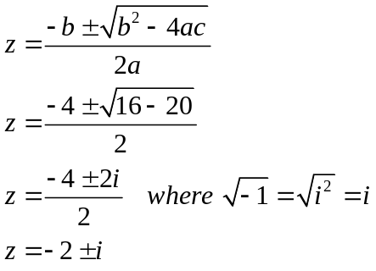
✓

✓

✓

(b) 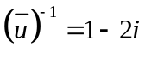
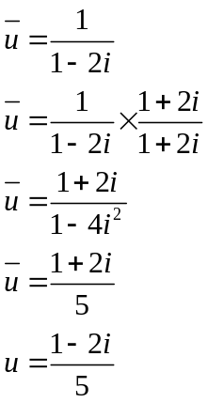
✓

✓

✓

(c) Real coefficients mean the roots appear in conjugate pairs.
✓

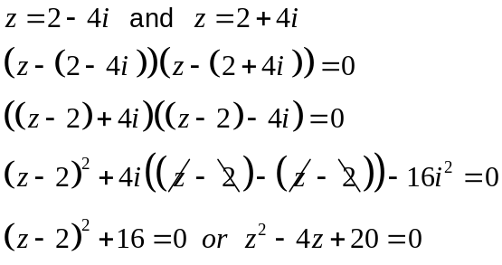
✓

✓

✓

(d) “If you pass your exams, you have studied hard.
✓

(e) “If you can’t watch the news on Channel 2, then you don’t have a TV.”
Question 14 (9 marks)
(a) 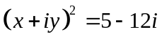
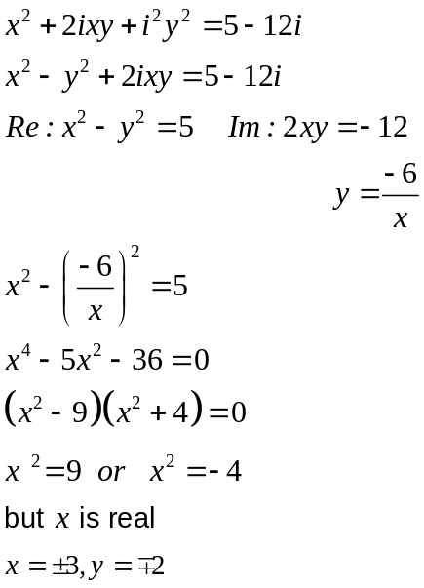
✓

✓

✓

✓

(b) (i) Solve for and , giving reasons.
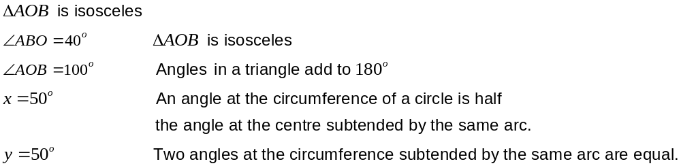
✓

✓

-1 no reasons

(ii) Solve for and , giving reasons.
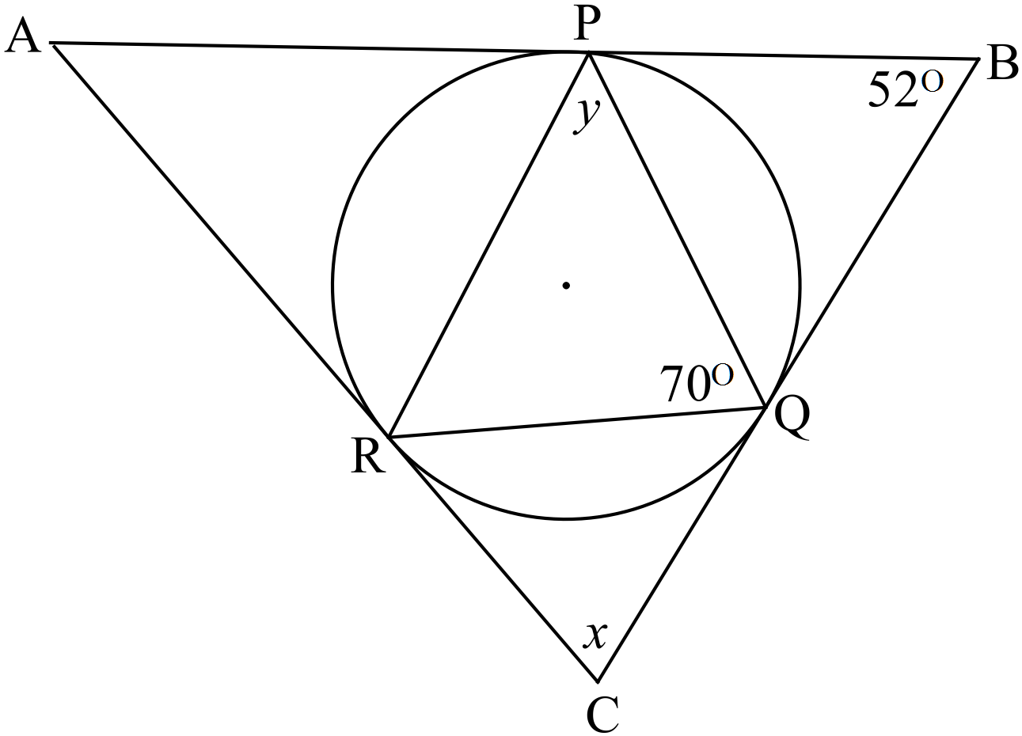
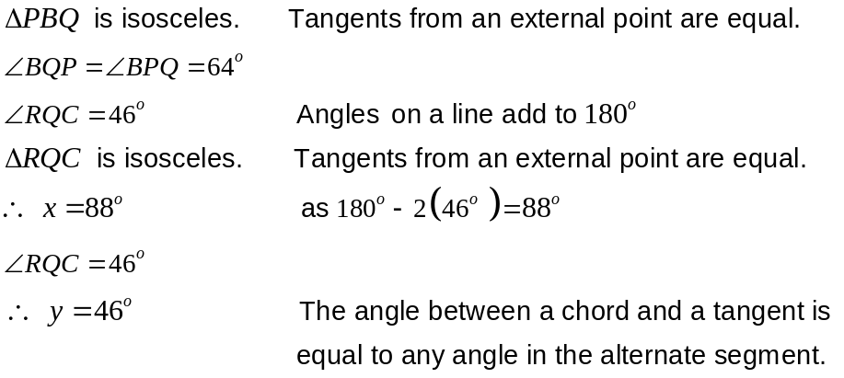
✓

✓

✓ Reasons

Question 15 (10 marks)

(a) Worst possible case: Seat then 2 at a time then leave a gap. One more person must be seated so there must be three together. ✓✓

(b) (i) 8x7x6 =336 ✓
(ii) 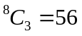 ✓
(c) (i)
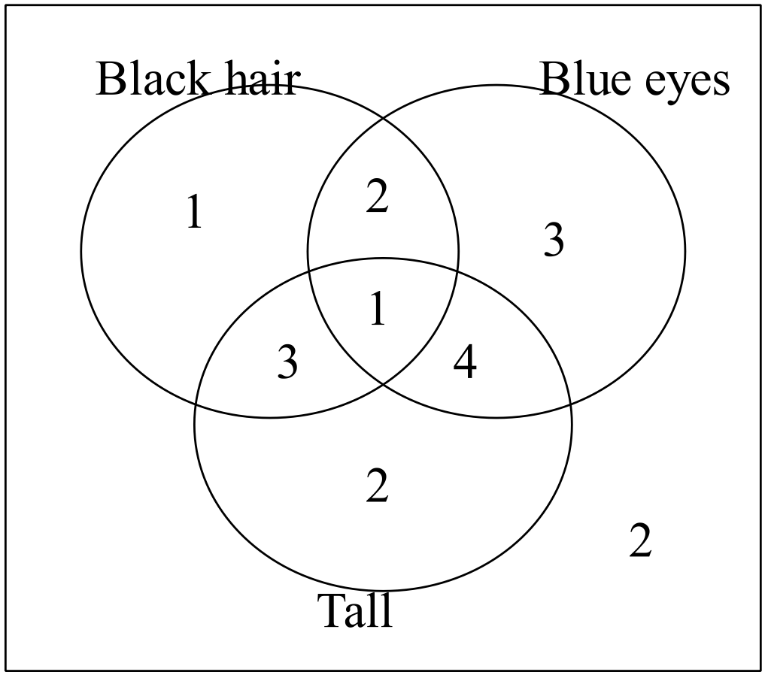
✓

Two students did not have black hair, nor blue eyes nor were tall. ✓
✓

(ii) 7

(d) Prove that 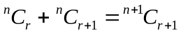
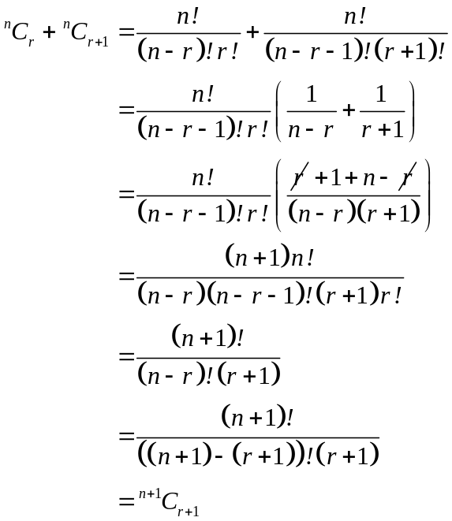
✓

✓

✓

Question 16 (10 marks)
(a) Prove, using a proof by contradiction, that is an irrational number.
Assume is rational.
i.e. 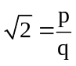 where p and q are relatively prime.
✓

✓✓

✓

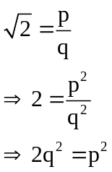
✓

✓✓

✓

Since p² is a square number then p is a multiple of 2.
✓

✓✓

✓

If p is a multiple of 2, then p = 2n where n is an integer.
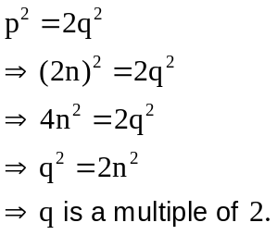
✓

✓✓

✓

✓

✓✓

✓

✓

✓✓

✓

This is a contradiction to p and q being relatively prime.

Therefore our original assumption is false.
Therefore 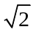 is irrational.

(b) Prove using mathematical induction, that 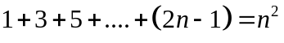
for any integer 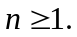
✓

✓✓

✓

Test for n = 1 1 = 1² so valid for n = 1.
Assume valid for n = k i.e. 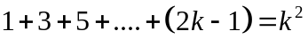
✓

✓✓

✓

Test for n = k+1
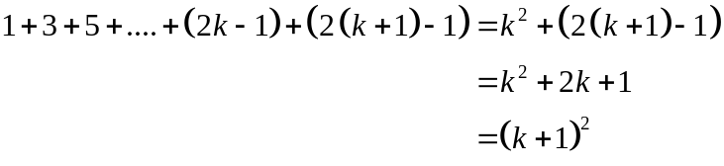
✓

✓✓

✓

So works for n = k+1
✓

✓✓

✓

Valid for n = 1, so valid for n = 2 etc
Therefore

Question 17 (12 marks)
(a) (i) 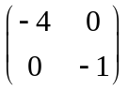
✓

✓✓

✓

(ii) 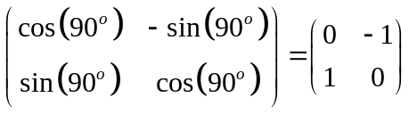
✓

✓✓

✓

(iii) 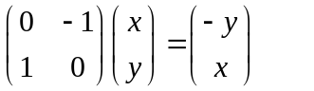
✓

✓✓

✓

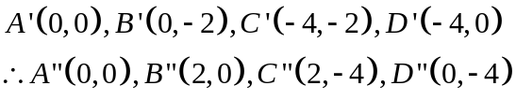
✓

✓✓

✓

(iv) 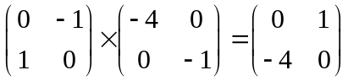
✓✓

✓✓

✓

(v) 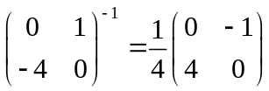
✓✓

✓✓

✓

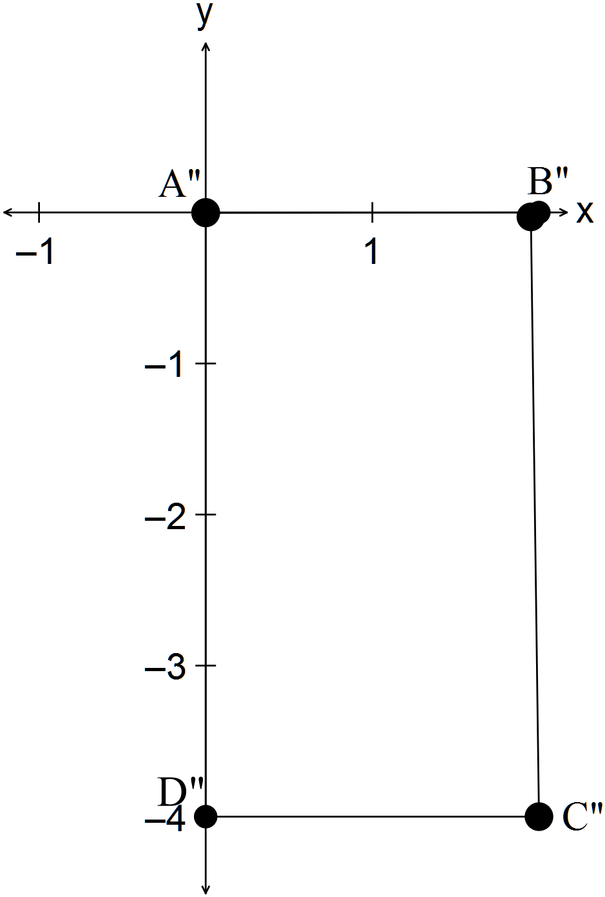(b) (i) Area ABCD x 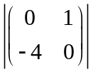= Area A’’B’’C’’D’’
✓✓

✓✓

✓

(ii) Area ABCD = 2
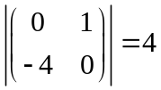
✓
Area A’’B’’C’’D’’ = 8
Area ABCD x = 2 x 4 = 8
✓
Yes, the method works.
Question 18 (8 marks)
(a) 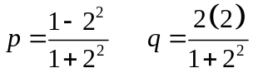
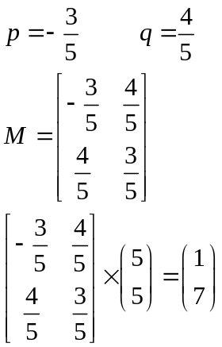
✓
✓
✓
The first reflected point is P’(1, 7)

(b) 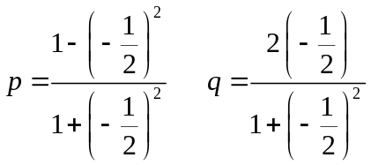
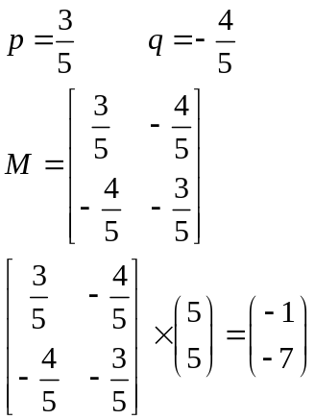
✓
✓
✓
The second reflected point is P’’(-1, -7)
✓
(c) 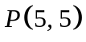 is exactly 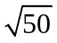 from the origin.
✓
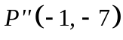 is also exactly from the origin.
Therefore the second reflected point is a rotation of P(5, 5) about the origin.

End of solutions

